**Visualization Tool For Electric Vehicle Charge And Range Analysis**

Submitted by

**D.SINDUJA**

(Reg. No. 12020U25026)

**G.SELSIYA**

(Reg. No. 12020U25024)

**C.SHALINI**

(Reg. No. 12020U25025)

**D.SIVAANANDHI**

(Reg. No. 12020U25027)

DEPARTMENT OF

BACHELOR OF SCIENCE IN MATHEMATICS



**KRISHNASAMY COLLEGE OF SCIENCE, ARTS & MANAGEMENT FOR WOMEN – CUDDALORE**

**PROJECT CONTENT**

1. INTRODUCTION
   1. Overview
   2. Purpose
2. PROBLEM DEFINITION & DESIGN THINKING
   1. Empathy Map
   2. Ideation & Brainstorming Map
3. RESULT
4. ADVANTAGES & DISADVANTAGES
5. APPLICFATIONS
6. CONCLUSION
7. FUTURE SCOPE
8. APPENDIX
9. SQL Source Code
10. HTML Source Code
11. **INTRODUCTION**
    1. **Overview**

A vehicle that can be powered by an electric motor that draws electricity from a battery and is capable of being charged from an external source and have an electric motor instead of an internal combustion engine. The Electric Vehicle (EV) is not new, but it has been receiving significantly more attention in recent years. Advances in both EV analytics and battery technologies have led to increased automotive market share. However, this growth is not attributed to hardware alone. The modern mechatronic vehicle marries electrical storage and propulsion systems with electronic sensors, controls, and actuators, integrated closely with software, secure data transfer, and data analysis, to form a comprehensive transportation solution. Advances in all these areas have contributed to the overall rise of EV’s, but the common thread that runs through all these elements is data analytics. The new EV’s are combined Electrical storage and propulsion systems with electronic sensors, controls, and actuators, integrated closely with software, secure data transfer to form a comprehensive transportation solution.

* 1. **Purpose**

The business requirements for analyzing the performance and efficiency of Electric cars include identifying KPIs, comparing performance across different parameters and brands also, identifying patterns and trends over time, identifying affecting factors, creating interactive dashboards and reports, identifying areas for improvement, making data-driven decisions, comparing to industry average and creating forecasting models for future performance. The ultimate goal is to gain insights and improve performance through data visualization techniques.

A literature survey is a method of researching existing literature and studies related to a specific topic. In the context of analyzing the performance and efficiency of electric vehicles, a literature survey would involve reviewing studies and articles that have been published on the topic of hotel performance and efficiency, as well as studies specific to electric vehicles. The literature survey would include sources such as academic journals, industry reports, and online articles. It would aim to identify key performance indicators (KPIs) and metrics that are commonly used to measure hotel performance and efficiency, as well as any best practices or strategies that have been identified for improving performance. The literature survey would also explore any existing research on electric vehicles specifically, and would aim to identify any unique challenges or opportunities that the electric vehicles faces in terms of performance and efficiency.

1. **PROBLEM DEFINITION & DESIGN THINKING**

**2.1 Empathy Map**

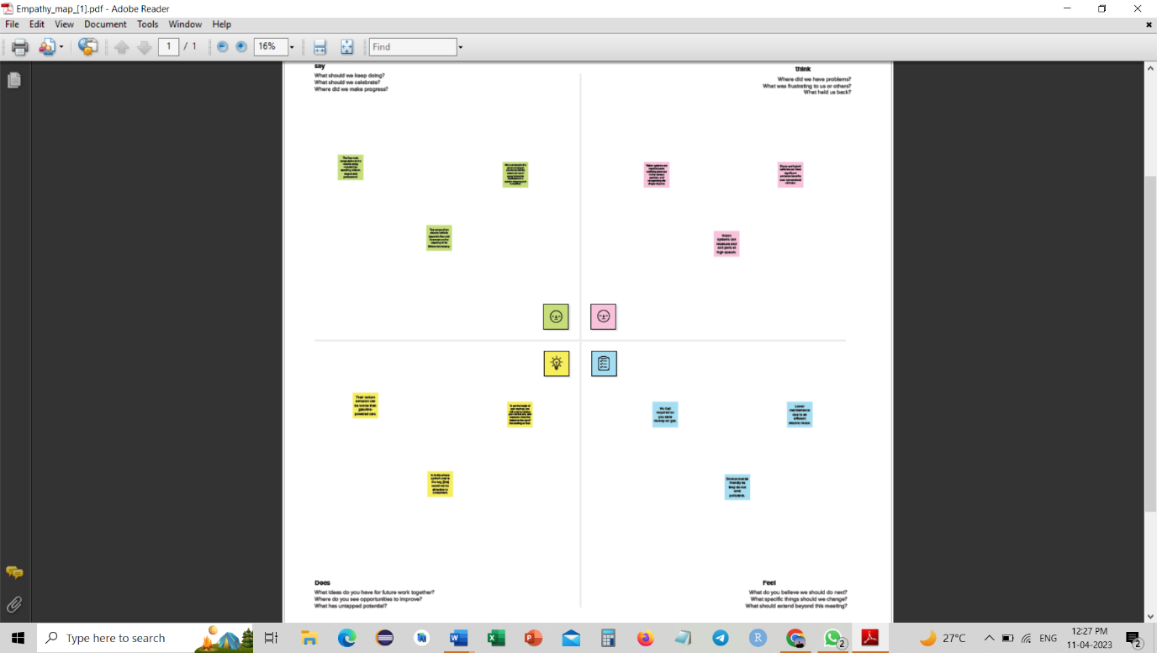

* 1. **Ideation & Brainstorming Map**

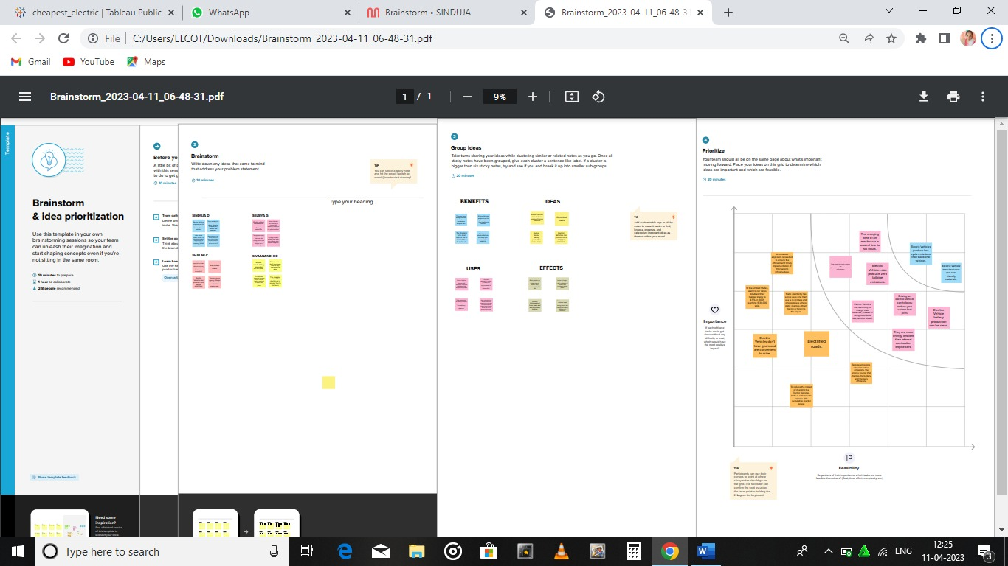

1. **RESULT**

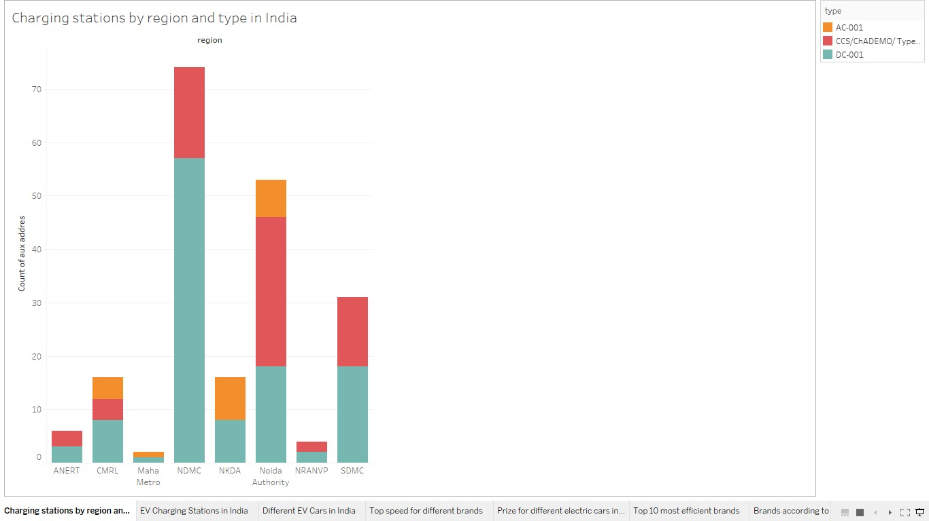

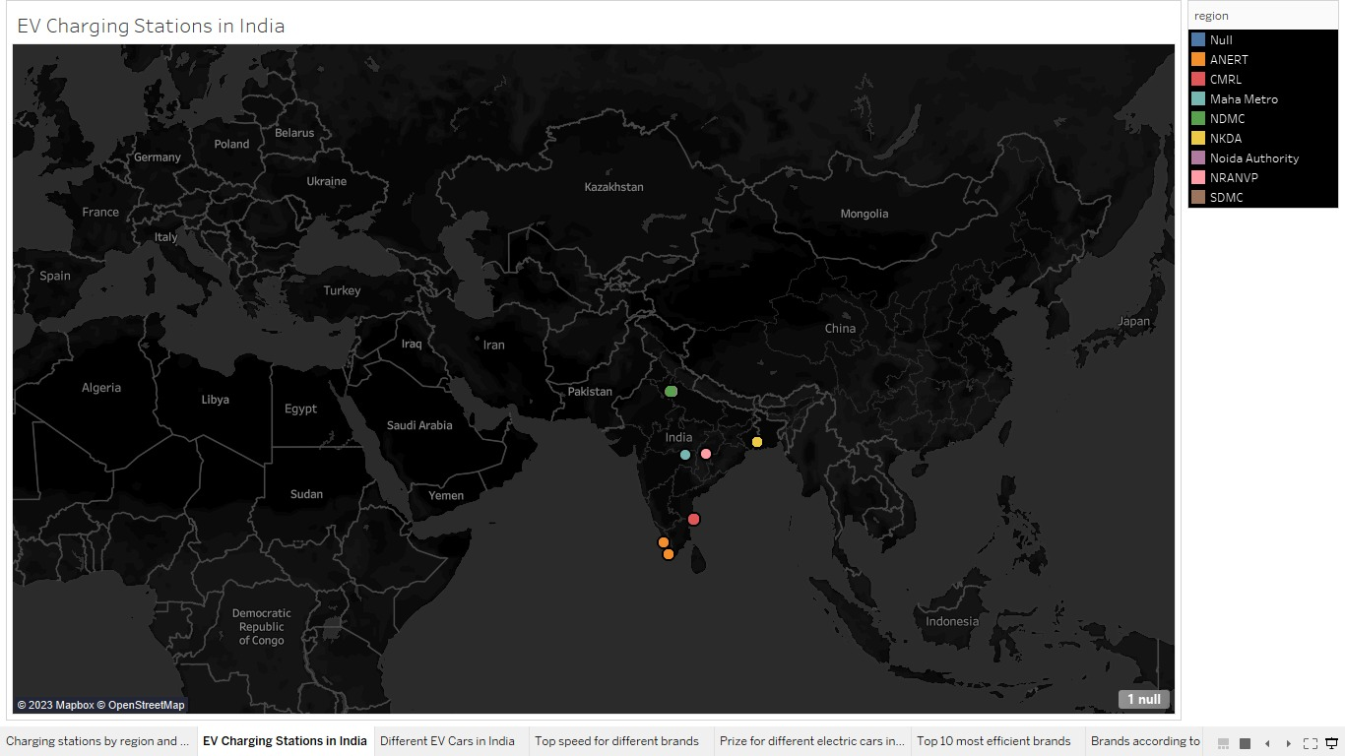

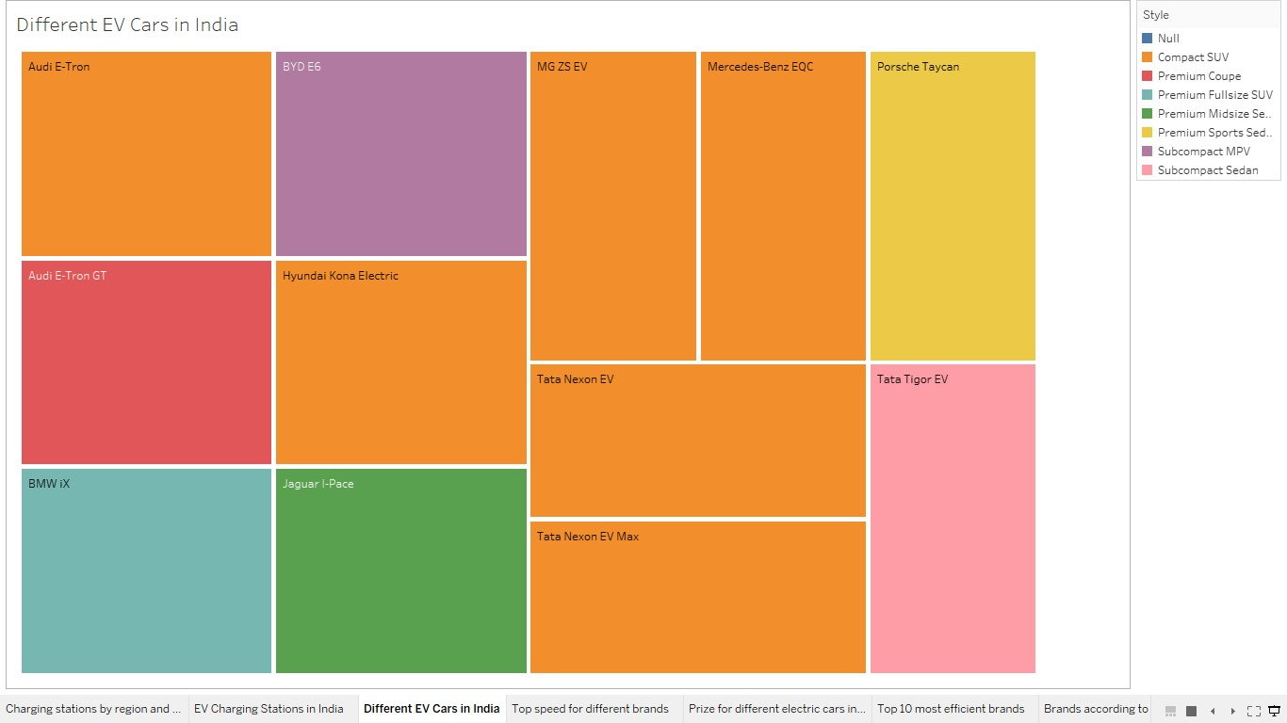

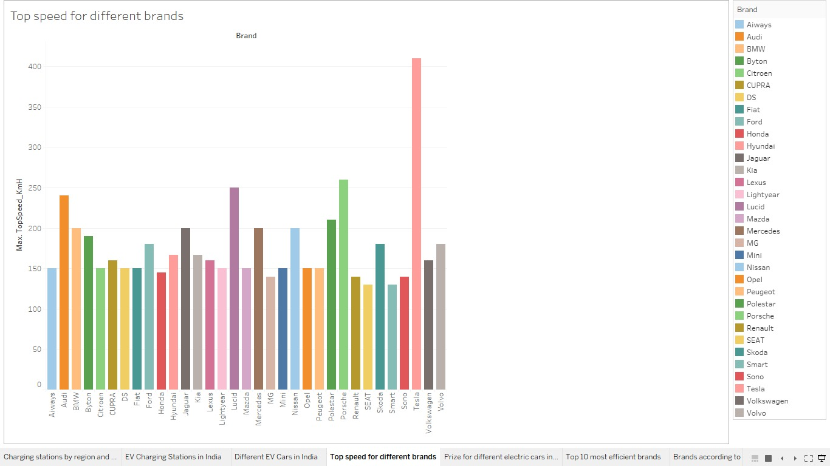

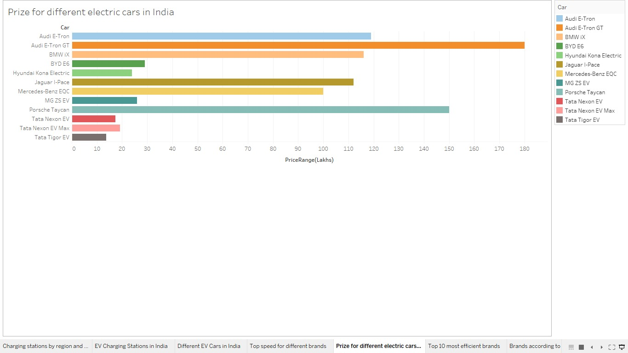

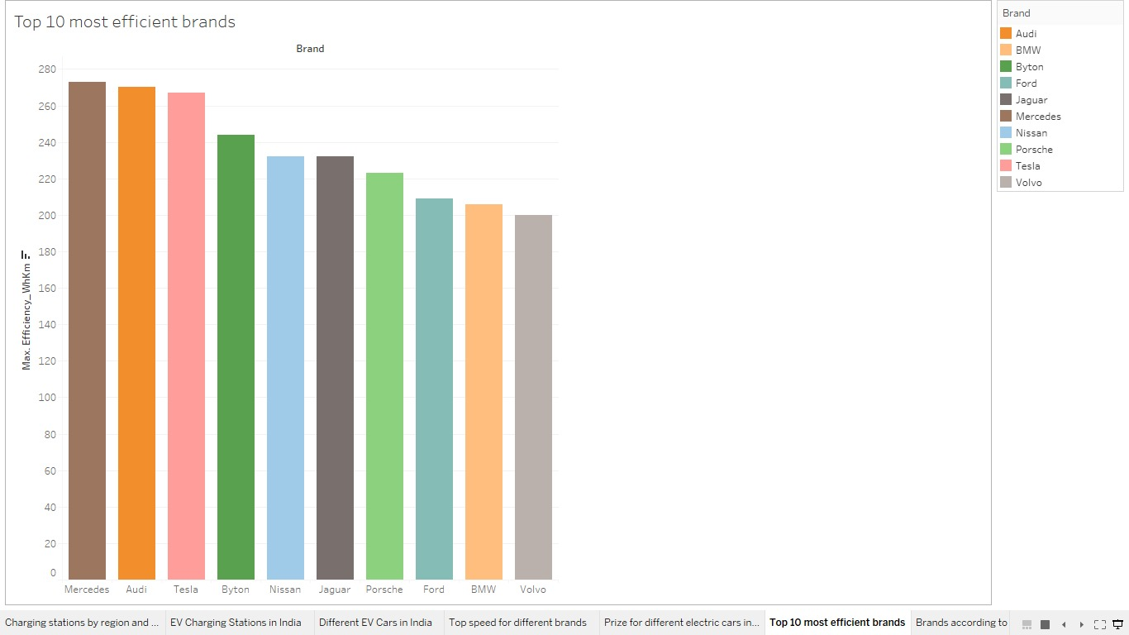

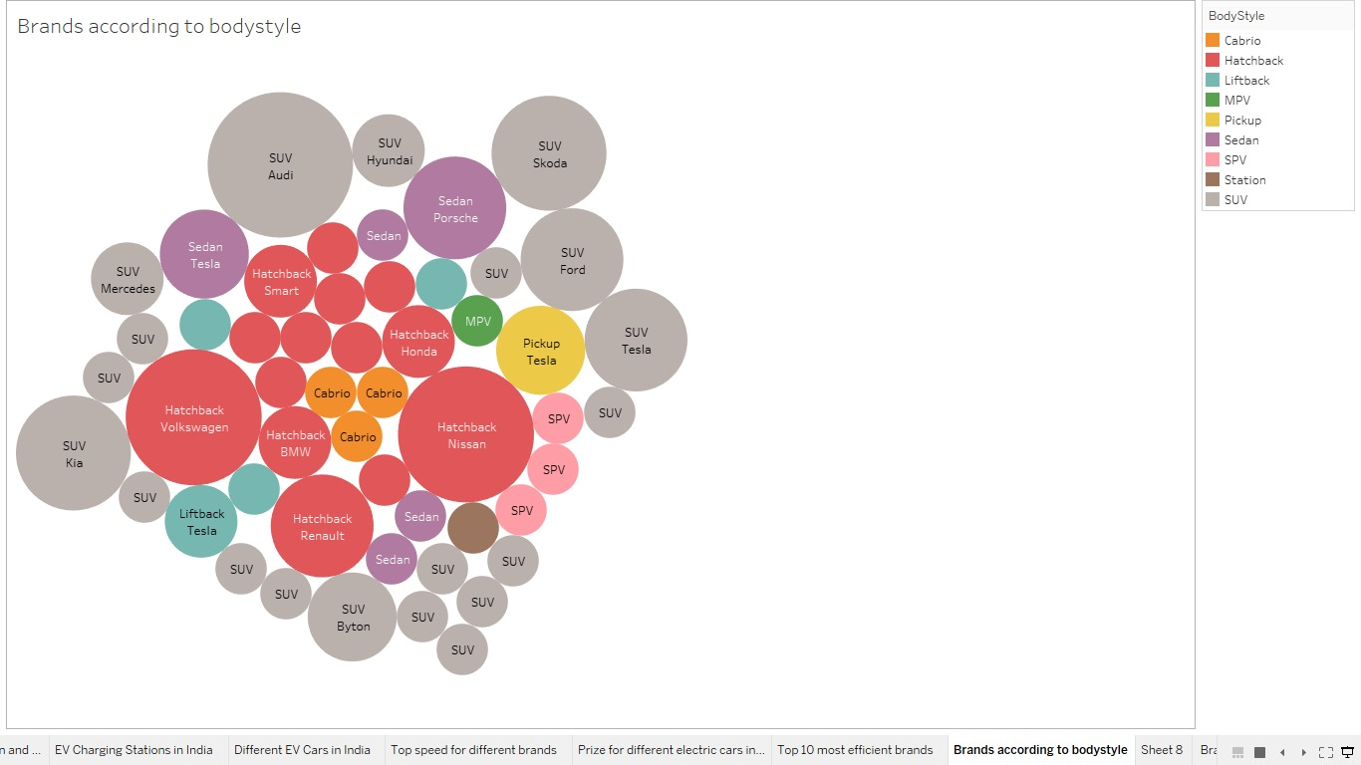

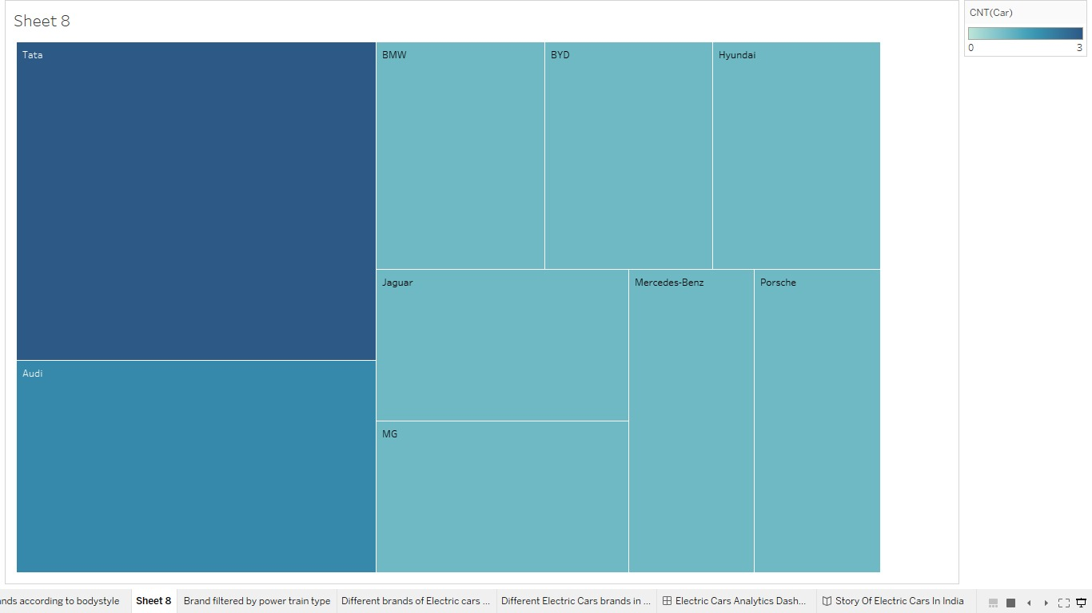

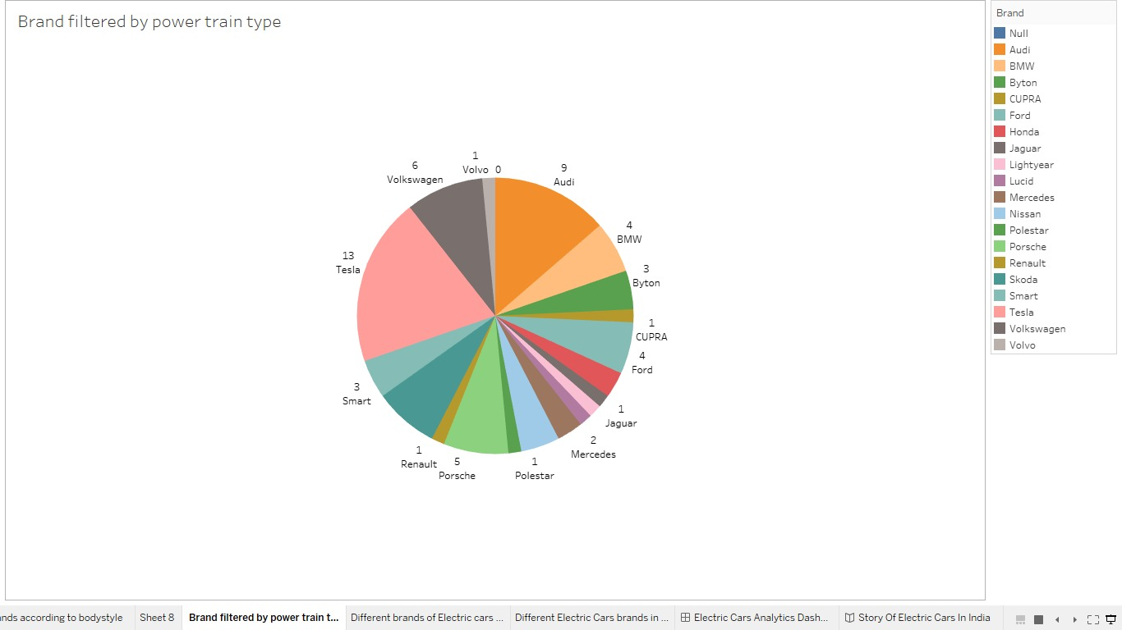

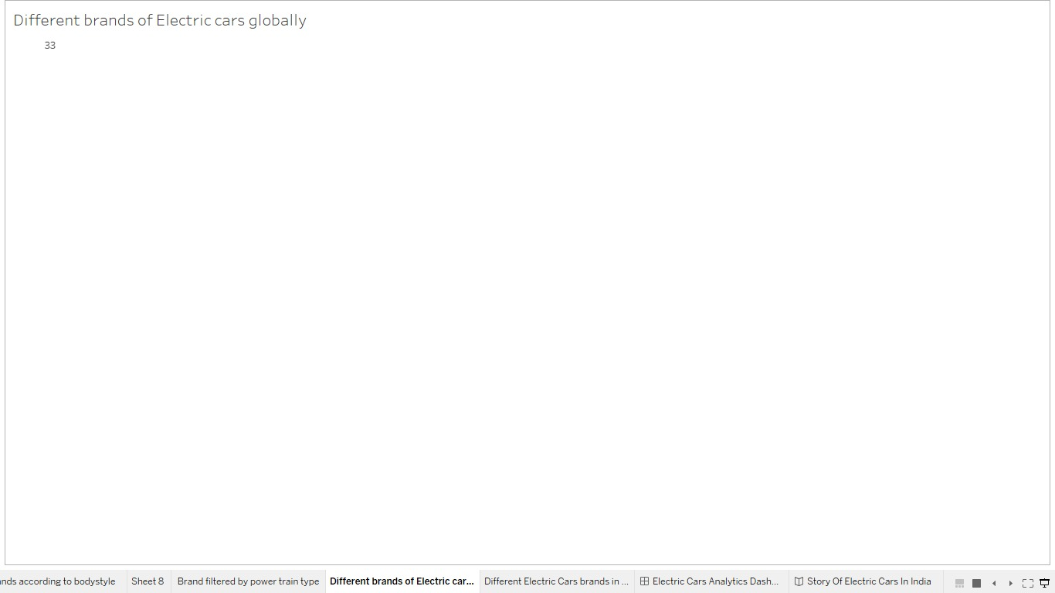

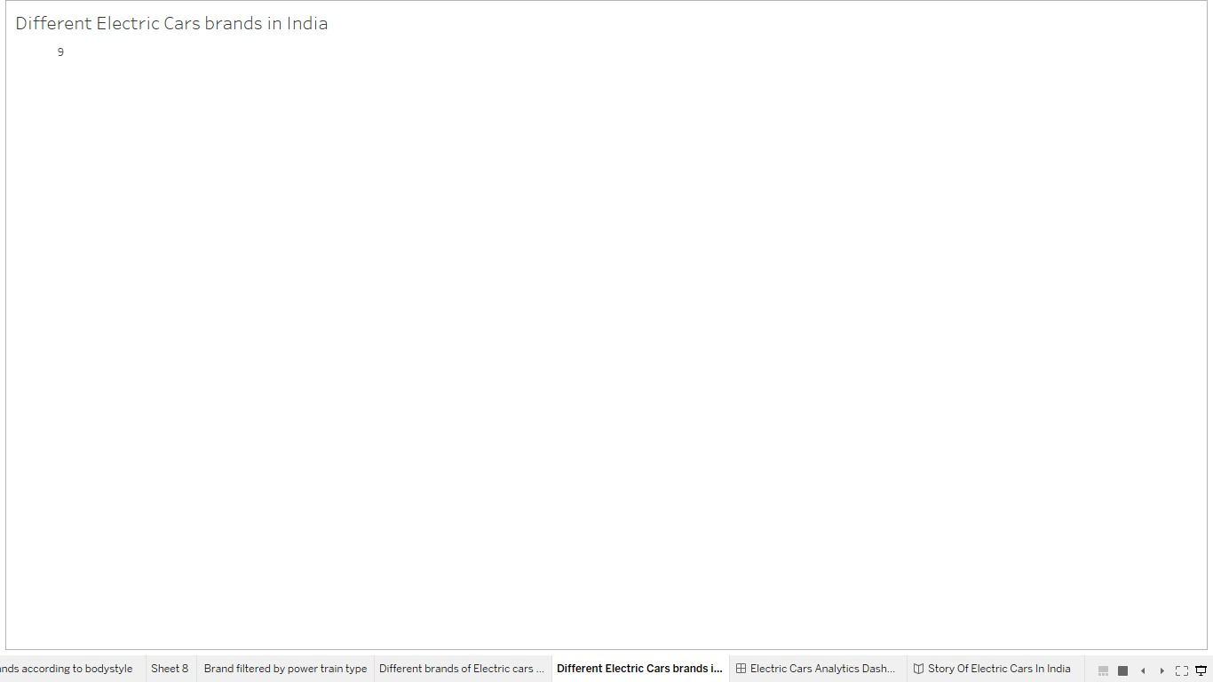

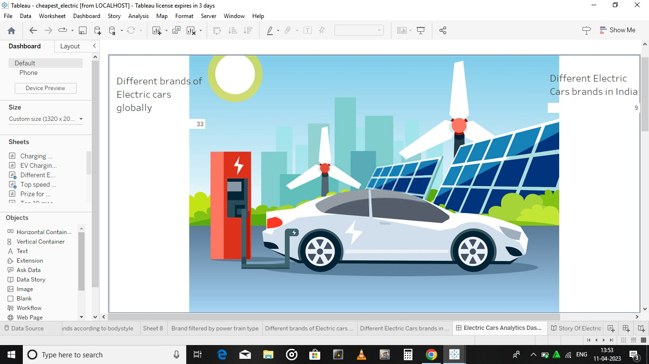

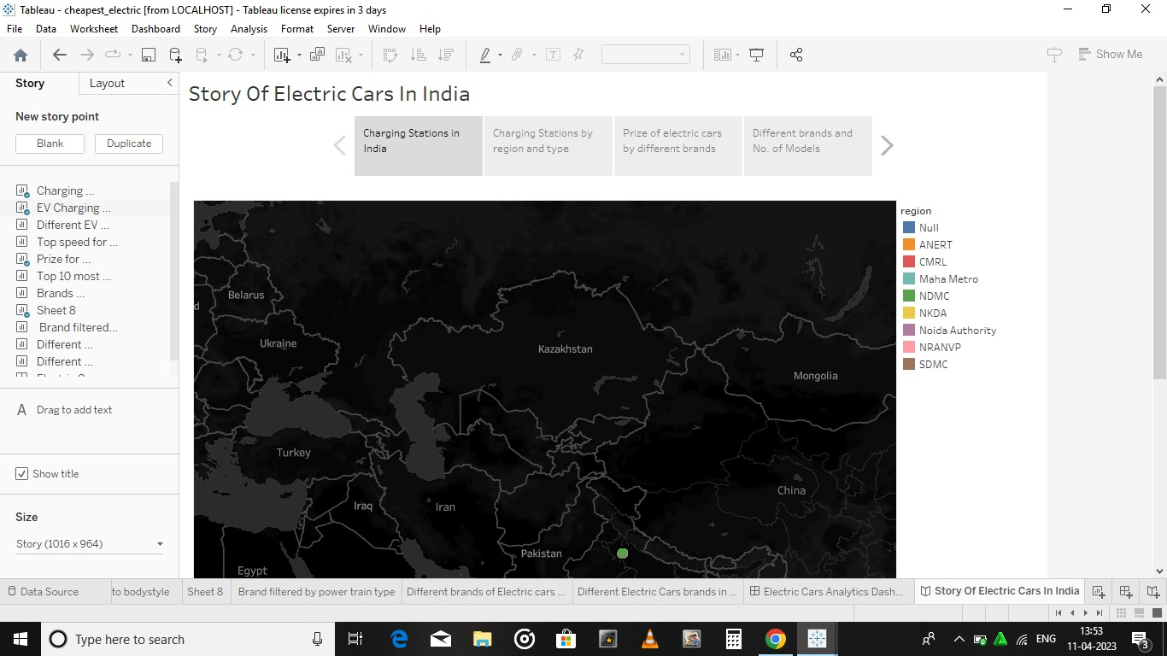

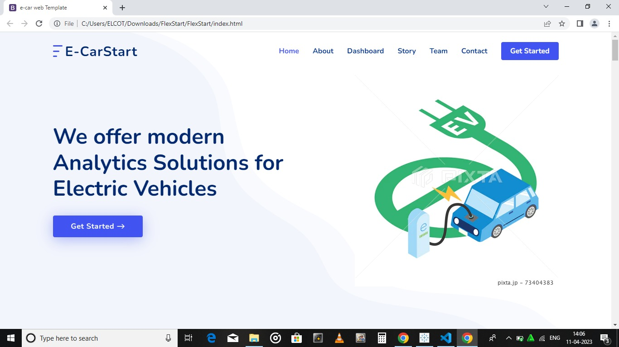

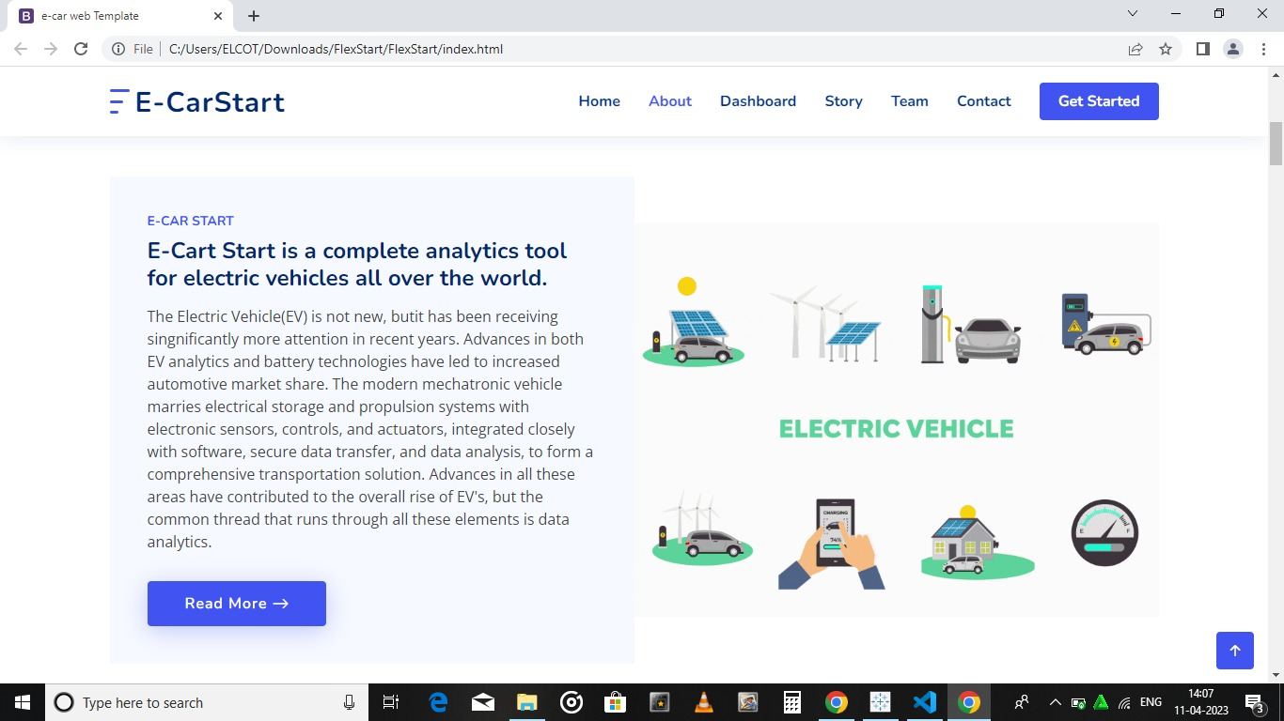

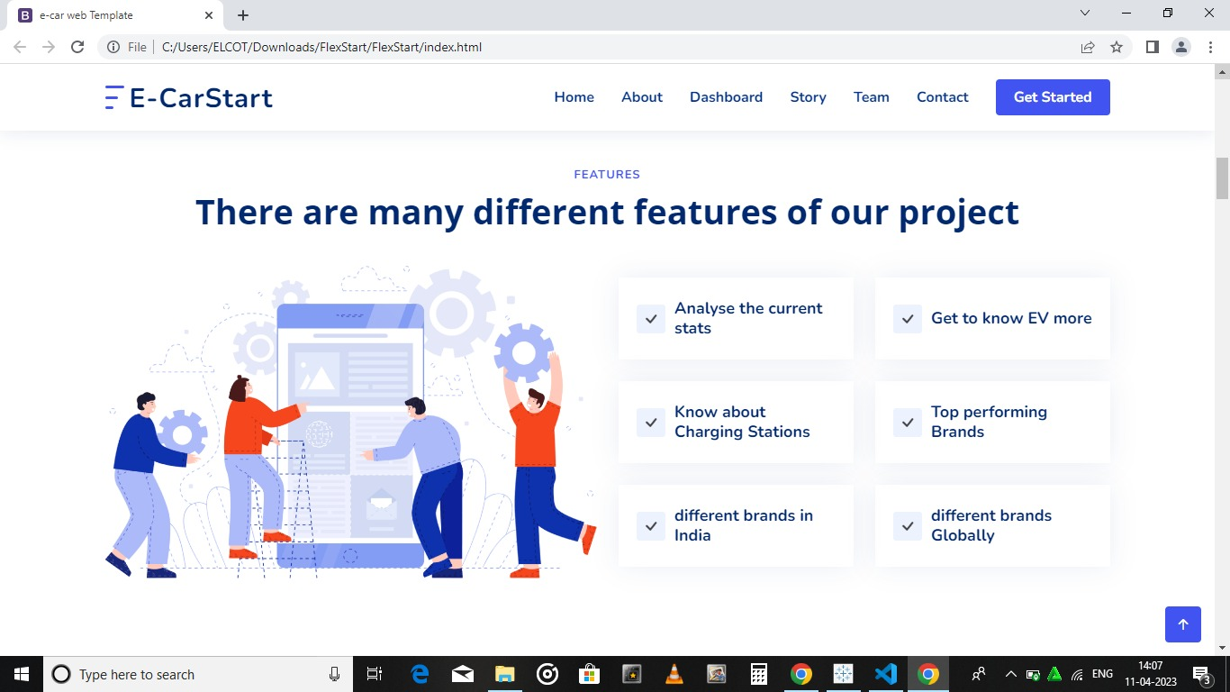

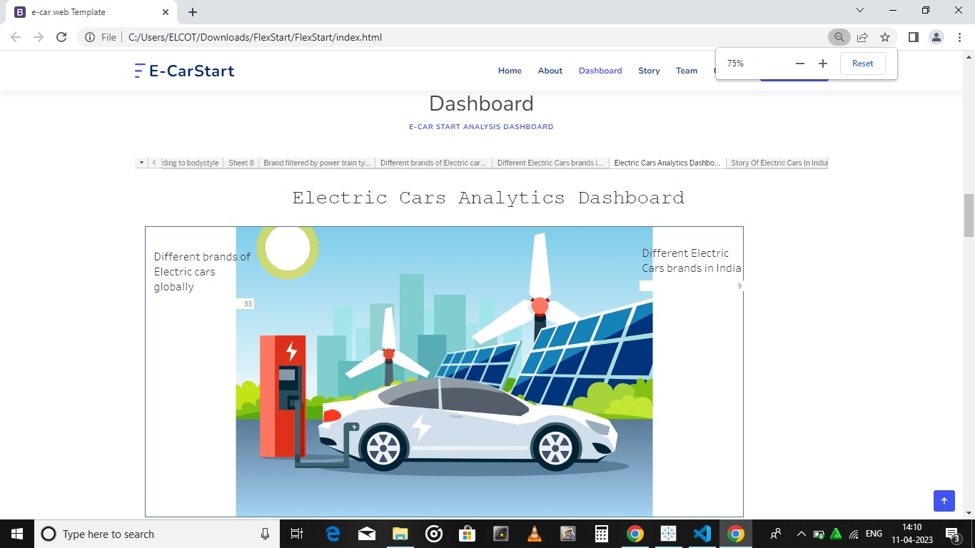

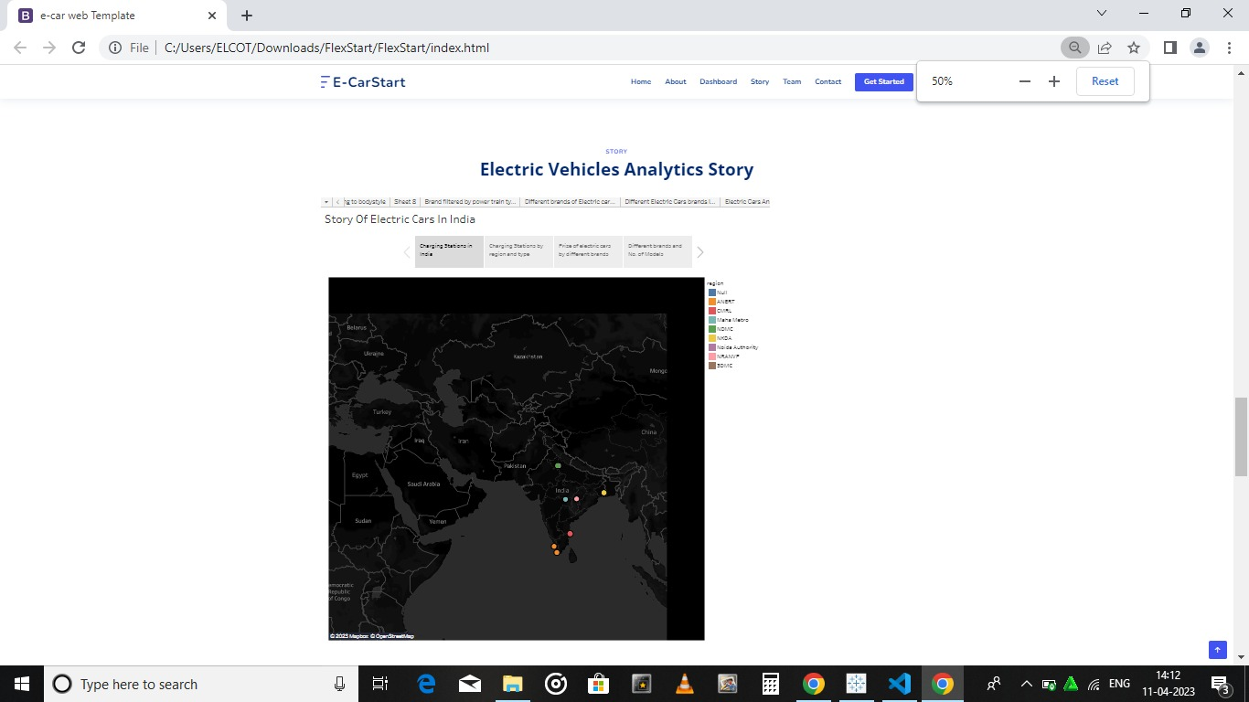

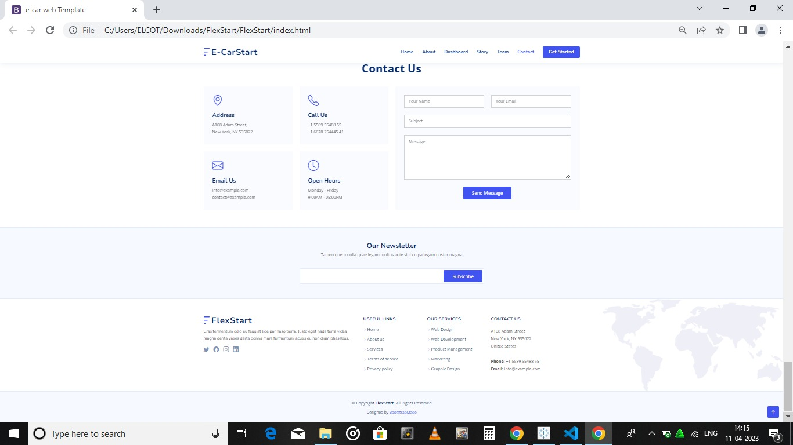

1. **ADVANTAGES & DISADVANTAGES**

* **ADVANTAGES**

**No fuel required so you save money on gas**  
Paying $0.10 per kW is the equivalent of driving on gasoline that costs less than $1 per gallon. On average, drivers save about $700 in fuel costs per year while driving electric cars.

**Environmental friendly as they do not emit pollutants**  
Drivers of electric vehicles have reduced CO2 emissions by more than 177,758,804 kg

**Lower maintenance due to an efficient electric motor**  
Electric motors have less parts that lead to less damage than a traditional non electric vehicle which means you save on operating cost!

**Better Performance**Electric cars are not only lighter but have faster acceleration

* **DISADVANTAGES:**

**The Inconvenience of Service Station**

The utilization of electric vehicles is still in its infancy. As a result, the stations that serve it are similarly built in small numbers. Even after traveling great distances, service locations where cars may be refuelled with electricity are few and far between.

**Low Energy**

The most significant disadvantage of electric vehicles is that they must be charged regularly. Aside from that, increasing the weight of these vehicles reduces their capacity. Electric cars with little energy and capacity can sometimes fall behind fuel-powered ones.

**Battery Expenses**

Although electric vehicles do not utilize gasoline, the batteries that power them are quite powerful. Aside from that, if the battery is not changed within a defined time interval, it might cause the vehicle to be damaged.

1. **APPLICATIONS**

An electric vehicle (EV) is a vehicle that runs on electric energy, powered by a motor. Since they do not emit exhaust gas, they are rapidly gaining popularity in recent years as eco-friendly vehicles. It is equipped with a high capacity lithium-ion battery pack and a high-power motor for driving. The output from the lithium-ion battery is DC current, but the drive motor of electric vehicles is an AC motor. Therefore, an inverter that converts the DC current into three-phase AC must also be installed.

A harness is also essential to ensure the safe and reliable transmission of high-voltage electricity. Electric vehicles use the back EMF from the motor to save energy. Therefore, in the development of motors and inverters for electric vehicles, it is also necessary to conduct tests using regenerative DC power supplies.

The most common battery voltage installed in electric vehicles is around 300 V to 400 V. Motor, and battery capacities are expected to become high voltage and high power in the future in order to improve driving range.

Matsusada Precision has a models of DC-stabilized power supplies and regenerative power supplies that can be used to evaluate various electrical components such as motors, inverters, and DC/DC converters. We also have a models that can handle high voltages of 800 V or more, so we can make proposals in anticipation of higher voltages.

1. **CONCLUSION**

The progress that the electric vehicle industry has seen in recent years is not only extremely welcomed, but highly necessary in light of the increasing global greenhouse gas levels. As demonstrated within the economic, social, and environmental analysis sections of this webpage, the benefits of electric vehicles far surpass the costs. The biggest obstacle to the widespread adoption of electric-powered transportation is cost related, as gasoline and the vehicles that run on it are readily available, convenient, and less costly. As is demonstrated in our timeline, we hope that over the course of the next decade technological advancements and policy changes will help ease the transition from traditional fuel-powered vehicles. Additionally, the realization and success of this industry relies heavily on the global population, and it is our hope that through mass marketing and environmental education programs people will feel incentivized and empowered to drive an electric-powered vehicle. Each person can make a difference, so go electric and help make a difference!

1. **FUTURE SCOPE**

Electric vehicles (EV) is the future not only of transport but of our planet. Can electric vehicles ever face a more serious form of gridlock however? These vehicles are plugged into a charging station at a low voltage. There are no emissions released from these vehicles.

But what if you have an electric vehicle that gets charged up from home electricity or by solar energy. What if you can use this charge to power your home and your garage. You will no longer need to fear the impact of fuel exporters. This means that electric vehicle drivers will be looking at long trips and camping. A home built electric vehicle will reduce the carbon footprint of the family and it will also lower electricity bills.

The future potential of electric vehicles is enormous. The obvious starting point for these vehicles is thecharging station. This is however only the first step in a potential journey which will see charge Banks and other industrial areas as well as homes and cities. The future scope of electric vehicles is therefore massive.

The technology for electric vehicles has been around since the 70’s in labs such as NASA. The present day technology will no doubt be far more advanced in a few years time. Some believe that we will soon see electric vehicles that can power themselves by harvesting energy from their environment. Such vehicles will require very little maintenance and can even run off alternative energy sources such as wind.

1. **APPENDIX**
2. **SQL Source Code**
3. create schema ele_visualization;
4. use ele_visualization;
5. select*from cheape_ele_car;
6. select*from ele_vehicle_charging;
7. select*from elecardata_clean;
8. select*from ev_india;
9. **HTML Source Code**

1. <!DOCTYPE html>

<html lang="en">

<head>

<meta charset="utf-8">

<meta content="width=device-width, initial-scale=1.0" name="viewport">

<title>e-car web Template</title>

<meta content="" name="description">

<meta content="" name="keywords">

<!-- Favicons -->

<link href="assets/img/favicon.png" rel="icon">

<link href="assets/img/apple-touch-icon.png" rel="apple-touch-icon">

<!-- Google Fonts -->

<link href="https://fonts.googleapis.com/css?family=Open+Sans:300,300i,400,400i,600,600i,700,700i|Nunito:300,300i,400,400i,600,600i,700,700i|Poppins:300,300i,400,400i,500,500i,600,600i,700,700i" rel="stylesheet">

<!-- Vendor CSS Files -->

<link href="assets/vendor/aos/aos.css" rel="stylesheet">

<link href="assets/vendor/bootstrap/css/bootstrap.min.css" rel="stylesheet">

<link href="assets/vendor/bootstrap-icons/bootstrap-icons.css" rel="stylesheet">

<link href="assets/vendor/glightbox/css/glightbox.min.css" rel="stylesheet">

<link href="assets/vendor/remixicon/remixicon.css" rel="stylesheet">

<link href="assets/vendor/swiper/swiper-bundle.min.css" rel="stylesheet">

<!-- Template Main CSS File -->

<link href="assets/css/style.css" rel="stylesheet">

<!-- =======================================================

* Template Name: FlexStart

* Updated: Mar 10 2023 with Bootstrap v5.2.3

* Template URL: https://bootstrapmade.com/flexstart-bootstrap-startup-template/

* Author: BootstrapMade.com

* License: https://bootstrapmade.com/license/ ======================================================== -->

</head>

<body>

<!-- ======= Header ======= -->

<header id="header" class="header fixed-top">

<div class="container-fluid container-xl d-flex align-items-center justify-content-between">

<a href="index.html" class="logo d-flex align-items-center">

<img src="assets/img/logo.png" alt="">

<span>E-CarStart</span>

</a>

<nav id="navbar" class="navbar">

<ul>

<li><a class="nav-link scrollto active" href="#hero">Home</a></li>

<li><a class="nav-link scrollto" href="#about">About</a></li>

<li><a class="nav-link scrollto" href="#services">Dashboard</a></li>

<li><a class="nav-link scrollto" href="#portfolio">Story</a></li>

<li><a class="nav-link scrollto" href="#team">Team</a></li>

<li><a class="nav-link scrollto" href="#contact">Contact</a></li>

<li><a class="getstarted scrollto" href="#about">Get Started</a></li>

</ul>

<i class="bi bi-list mobile-nav-toggle"></i>

</nav><!-- .navbar -->

</div>

</header><!-- End Header -->

<!-- ======= Hero Section ======= -->

<section id="hero" class="hero d-flex align-items-center">

<div class="container">

<div class="row">

<div class="col-lg-6 d-flex flex-column justify-content-center">

<h1 data-aos="fade-up">We offer modern Analytics<span> Solutions for Electric</span> <span>Vehicles</span></h1>

<div data-aos="fade-up" data-aos-delay="600">

<div class="text-center text-lg-start">

<a href="#about" class="btn-get-started scrollto d-inline-flex align-items-center justify-content-center align-self-center">

<span>Get Started</span>

<i class="bi bi-arrow-right"></i>

</a>

</div>

</div>

</div>

<div class="col-lg-6 hero-img" data-aos="zoom-out" data-aos-delay="200">

<img src="assets/img/hero-img.png" class="img-fluid" alt="">

</div>

</div>

</div>

</section><!-- End Hero -->

<main id="main">

<!-- ======= About Section ======= -->

<section id="about" class="about">

<div class="container" data-aos="fade-up">

<div class="row gx-0">

<div class="col-lg-6 d-flex flex-column justify-content-center" data-aos="fade-up" data-aos-delay="200">

<div class="content">

<h3>E-CAR START</h3>

<h2>E-Cart Start is a complete analytics tool for electric vehicles all over the world.</h2>

<p>

The Electric Vehicle(EV) is not new, butit has been receiving singnificantly more attention in recent years. Advances in both EV analytics and battery technologies have led to increased automotive market share. The modern mechatronic vehicle marries electrical storage and propulsion systems with electronic sensors, controls, and actuators, integrated closely with software, secure data transfer, and data analysis, to form a comprehensive transportation solution. Advances in all these areas have contributed to the overall rise of EV's, but the common thread that runs through all these elements is data analytics.

</p>

<div class="text-center text-lg-start">

<a href="#" class="btn-read-more d-inline-flex align-items-center justify-content-center align-self-center">

<span>Read More</span>

<i class="bi bi-arrow-right"></i>

</a>

</div>

</div>

</div>

<div class="col-lg-6 d-flex align-items-center" data-aos="zoom-out" data-aos-delay="200">

<img src="assets/img/about.jpg" class="img-fluid" alt="">

</div>

</div>

</div>

</section><!-- End About Section -->

<!-- ======= Features Section ======= -->

<section id="features" class="features">

<div class="container" data-aos="fade-up">

<header class="section-header">

<h2>Features</h2>

<p>There are many different features of our project</p>

</header>

<div class="row">

<div class="col-lg-6">

<img src="assets/img/features.png" class="img-fluid" alt="">

</div>

<div class="col-lg-6 mt-5 mt-lg-0 d-flex">

<div class="row align-self-center gy-4">

<div class="col-md-6" data-aos="zoom-out" data-aos-delay="200">

<div class="feature-box d-flex align-items-center">

<i class="bi bi-check"></i>

<h3>Analyse the current stats</h3>

</div>

</div>

<div class="col-md-6" data-aos="zoom-out" data-aos-delay="300">

<div class="feature-box d-flex align-items-center">

<i class="bi bi-check"></i>

<h3>Get to know EV more</h3>

</div>

</div>

<div class="col-md-6" data-aos="zoom-out" data-aos-delay="400">

<div class="feature-box d-flex align-items-center">

<i class="bi bi-check"></i>

<h3>Know about Charging Stations</h3>

</div>

</div>

<div class="col-md-6" data-aos="zoom-out" data-aos-delay="500">

<div class="feature-box d-flex align-items-center">

<i class="bi bi-check"></i>

<h3>Top performing Brands</h3>

</div>

</div>

<div class="col-md-6" data-aos="zoom-out" data-aos-delay="600">

<div class="feature-box d-flex align-items-center">

<i class="bi bi-check"></i>

<h3>different brands in India</h3>

</div>

</div>

<div class="col-md-6" data-aos="zoom-out" data-aos-delay="700">

<div class="feature-box d-flex align-items-center">

<i class="bi bi-check"></i>

<h3>different brands Globally</h3>

</div>

</div>

</div>

</div>

</div> <!-- / row -->

<!-- Feature Tabs -->

<div class="row feture-tabs" data-aos="fade-up">

<div class="col-lg-6">

<h3>Overview of Electric Vehicle Sector</h3>

<!-- Tabs -->

<ul class="nav nav-pills mb-3">

<li>

<a class="nav-link active" data-bs-toggle="pill" href="#tab1">OVERVIEW</a>

</li>

<li>

<a class="nav-link" data-bs-toggle="pill" href="#tab2">PRICING</a>

</li>

</ul><!-- End Tabs -->

<!-- Tab Content -->

<div class="tab-content">

<div class="tab-pane fade show active" id="tab1">

The supply of fossil fuels is constantly decreasing. The situation is very alarming. It is time for the world to slowly adapt to electric vehicles.</p>

<div class="d-flex align-items-center mb-2">

<i class="bi bi-check2"></i>

<h4>A lot of change needs to happen</h4>

</div>

<p>Major carmarkers like Tesla and Porsche manufacture many electric vehicles.</p>

<div class="d-flex align-items-center mb-2">

<i class="bi bi-check2"></i>

<h4>The improvement of battery technology in recent years has led to the higher popularity of electric vehicles.</h4>

</div>

<p>Buying an electric vehicle can be a great choice for consumers. The drive quality, low noise levels, and convenience are really great.</p>

</div><!-- End Tab 1 Content -->

<div class="tab-pane fade show" id="tab2">

<p>Consequuntur inventore voluptates consequatur aut vel et. Eos doloribus expedita. Sapiente atque consequatur minima nihil quae aspernatur quo suscipit voluptatem.</p>

<div class="d-flex align-items-center mb-2">

<i class="bi bi-check2"></i>

<h4>Repudiandae rerum velit modi et officia quasi facilis</h4>

</div>

<p>Laborum omnis voluptates voluptas qui sit aliquam blanditiis. Sapiente minima commodi dolorum non eveniet magni quaerat nemo et.</p>

<div class="d-flex align-items-center mb-2">

<i class="bi bi-check2"></i>

<h4>Incidunt non veritatis illum ea ut nisi</h4>

</div>

<p>Non quod totam minus repellendus autem sint velit. Rerum debitis facere soluta tenetur. Iure molestiae assumenda sunt qui inventore eligendi voluptates nisi at. Dolorem quo tempora. Quia et perferendis.</p>

</div><!-- End Tab 2 Content -->

<div class="tab-pane fade show" id="tab3">

<p>Consequuntur inventore voluptates consequatur aut vel et. Eos doloribus expedita. Sapiente atque consequatur minima nihil quae aspernatur quo suscipit voluptatem.</p>

<div class="d-flex align-items-center mb-2">

<i class="bi bi-check2"></i>

<h4>Repudiandae rerum velit modi et officia quasi facilis</h4>

</div>

<p>Laborum omnis voluptates voluptas qui sit aliquam blanditiis. Sapiente minima commodi dolorum non eveniet magni quaerat nemo et.</p>

<div class="d-flex align-items-center mb-2">

<i class="bi bi-check2"></i>

<h4>Incidunt non veritatis illum ea ut nisi</h4>

</div>

<p>Non quod totam minus repellendus autem sint velit. Rerum debitis facere soluta tenetur. Iure molestiae assumenda sunt qui inventore eligendi voluptates nisi at. Dolorem quo tempora. Quia et perferendis.</p>

</div><!-- End Tab 3 Content -->

</div>

</div>

<div class="col-lg-6">

<img src="assets/img/features-2.png" class="img-fluid" alt="">

</div>

</div><!-- End Feature Tabs -->

</div>

</section><!-- End Features Section -->

<!-- ======= Services Section ======= -->

<section id="services" class="services">

<div class="container" data-aos="fade-up">

<header class="section-header">

<h1>Dashboard</h1>

<p><h2>E-car Start Analysis Dashboard</h2></p>

</header>

<div class='tableauPlaceholder' id='viz1681186406520' style='position: relative'><noscript><a href='#'><img alt=' ' src='https:&#47;&#47;public.tableau.com&#47;static&#47;images&#47;ch&#47;cheapest_electric&#47;ElectricCarsAnalyticsDashboard&#47;1_rss.png' style='border: none' /></a></noscript><object class='tableauViz' style='display:none;'><param name='host_url' value='https%3A%2F%2Fpublic.tableau.com%2F' /> <param name='embed_code_version' value='3' /> <param name='site_root' value='' /><param name='name' value='cheapest_electric&#47;ElectricCarsAnalyticsDashboard' /><param name='tabs' value='yes' /><param name='toolbar' value='yes' /><param name='static_image' value='https:&#47;&#47;public.tableau.com&#47;static&#47;images&#47;ch&#47;cheapest_electric&#47;ElectricCarsAnalyticsDashboard&#47;1.png' /> <param name='animate_transition' value='yes' /><param name='display_static_image' value='yes' /><param name='display_spinner' value='yes' /><param name='display_overlay' value='yes' /><param name='display_count' value='yes' /><param name='language' value='en-US' /></object></div> <script type='text/javascript'> var divElement = document.getElementById('viz1681186406520'); var vizElement = divElement.getElementsByTagName('object')[0]; if ( divElement.offsetWidth > 800 ) { vizElement.style.minWidth='1320px';vizElement.style.maxWidth='100%';vizElement.style.minHeight='2050px';vizElement.style.maxHeight=(divElement.offsetWidth*0.75)+'px';} else if ( divElement.offsetWidth > 500 ) { vizElement.style.minWidth='1320px';vizElement.style.maxWidth='100%';vizElement.style.minHeight='2050px';vizElement.style.maxHeight=(divElement.offsetWidth*0.75)+'px';} else { vizElement.style.minWidth='1016px';vizElement.style.maxWidth='100%';vizElement.style.minHeight='2600px';vizElement.style.maxHeight=(divElement.offsetWidth*1.77)+'px';} var scriptElement = document.createElement('script'); scriptElement.src = 'https://public.tableau.com/javascripts/api/viz_v1.js'; vizElement.parentNode.insertBefore(scriptElement, vizElement); </script>

</div>

</section><!-- End Services Section -->

<!-- ======= Pricing Section ======= -->

<section id="pricing" class="pricing">

<div class="container" data-aos="fade-up">

<header class="section-header">

<h2>STORY</h2>

<p>Electric Vehicles Analytics Story</p>

</header>

<div class='tableauPlaceholder' id='viz1681190658415' style='position: relative'><noscript><a href='#'><img alt=' ' src='https:&#47;&#47;public.tableau.com&#47;static&#47;images&#47;ch&#47;cheapest_electric&#47;StoryOfElectricCarsInIndia&#47;1_rss.png' style='border: none' /></a></noscript><object class='tableauViz' style='display:none;'><param name='host_url' value='https%3A%2F%2Fpublic.tableau.com%2F' /> <param name='embed_code_version' value='3' /> <param name='site_root' value='' /><param name='name' value='cheapest_electric&#47;StoryOfElectricCarsInIndia' /><param name='tabs' value='yes' /><param name='toolbar' value='yes' /><param name='static_image' value='https:&#47;&#47;public.tableau.com&#47;static&#47;images&#47;ch&#47;cheapest_electric&#47;StoryOfElectricCarsInIndia&#47;1.png' /> <param name='animate_transition' value='yes' /><param name='display_static_image' value='yes' /><param name='display_spinner' value='yes' /><param name='display_overlay' value='yes' /><param name='display_count' value='yes' /><param name='language' value='en-US' /></object></div> <script type='text/javascript'> var divElement = document.getElementById('viz1681190658415'); var vizElement = divElement.getElementsByTagName('object')[0]; vizElement.style.width='1016px';vizElement.style.height='1014px'; var scriptElement = document.createElement('script'); scriptElement.src = 'https://public.tableau.com/javascripts/api/viz_v1.js'; vizElement.parentNode.insertBefore(scriptElement, vizElement); </script>

</div>

</section><!-- End Pricing Section -->

<!-- ======= Testimonials Section ======= -->

<section id="testimonials" class="testimonials">

<div class="container" data-aos="fade-up">

<header class="section-header">

<h2>Testimonials</h2>

<p>What they are saying about us</p>

</header>

<div class="testimonials-slider swiper" data-aos="fade-up" data-aos-delay="200">

<div class="swiper-wrapper">

<div class="swiper-slide">

<div class="testimonial-item">

<div class="stars">

<i class="bi bi-star-fill"></i><i class="bi bi-star-fill"></i><i class="bi bi-star-fill"></i><i class="bi bi-star-fill"></i><i class="bi bi-star-fill"></i>

</div>

<p>

Proin iaculis purus consequat sem cure digni ssim donec porttitora entum suscipit rhoncus. Accusantium quam, ultricies eget id, aliquam eget nibh et. Maecen aliquam, risus at semper.

</p>

<div class="profile mt-auto">

<img src="assets/img/testimonials/testimonials-1.jpg" class="testimonial-img" alt="">

<h3>Saul Goodman</h3>

<h4>Ceo &amp; Founder</h4>

</div>

</div>

</div><!-- End testimonial item -->

<div class="swiper-slide">

<div class="testimonial-item">

<div class="stars">

<i class="bi bi-star-fill"></i><i class="bi bi-star-fill"></i><i class="bi bi-star-fill"></i><i class="bi bi-star-fill"></i><i class="bi bi-star-fill"></i>

</div>

<p>

Export tempor illum tamen malis malis eram quae irure esse labore quem cillum quid cillum eram malis quorum velit fore eram velit sunt aliqua noster fugiat irure amet legam anim culpa.

</p>

<div class="profile mt-auto">

<img src="assets/img/testimonials/testimonials-2.jpg" class="testimonial-img" alt="">

<h3>Sara Wilsson</h3>

<h4>Designer</h4>

</div>

</div>

</div><!-- End testimonial item -->

<div class="swiper-slide">

<div class="testimonial-item">

<div class="stars">

<i class="bi bi-star-fill"></i><i class="bi bi-star-fill"></i><i class="bi bi-star-fill"></i><i class="bi bi-star-fill"></i><i class="bi bi-star-fill"></i>

</div>

<p>

Enim nisi quem export duis labore cillum quae magna enim sint quorum nulla quem veniam duis minim tempor labore quem eram duis noster aute amet eram fore quis sint minim.

</p>

<div class="profile mt-auto">

<img src="assets/img/testimonials/testimonials-3.jpg" class="testimonial-img" alt="">

<h3>Jena Karlis</h3>

<h4>Store Owner</h4>

</div>

</div>

</div><!-- End testimonial item -->

<div class="swiper-slide">

<div class="testimonial-item">

<div class="stars">

<i class="bi bi-star-fill"></i><i class="bi bi-star-fill"></i><i class="bi bi-star-fill"></i><i class="bi bi-star-fill"></i><i class="bi bi-star-fill"></i>

</div>

<p>

Fugiat enim eram quae cillum dolore dolor amet nulla culpa multos export minim fugiat minim velit minim dolor enim duis veniam ipsum anim magna sunt elit fore quem dolore labore illum veniam.

</p>

<div class="profile mt-auto">

<img src="assets/img/testimonials/testimonials-4.jpg" class="testimonial-img" alt="">

<h3>Matt Brandon</h3>

<h4>Freelancer</h4>

</div>

</div>

</div><!-- End testimonial item -->

<div class="swiper-slide">

<div class="testimonial-item">

<div class="stars">

<i class="bi bi-star-fill"></i><i class="bi bi-star-fill"></i><i class="bi bi-star-fill"></i><i class="bi bi-star-fill"></i><i class="bi bi-star-fill"></i>

</div>

<p>

Quis quorum aliqua sint quem legam fore sunt eram irure aliqua veniam tempor noster veniam enim culpa labore duis sunt culpa nulla illum cillum fugiat legam esse veniam culpa fore nisi cillum quid.

</p>

<div class="profile mt-auto">

<img src="assets/img/testimonials/testimonials-5.jpg" class="testimonial-img" alt="">

<h3>John Larson</h3>

<h4>Entrepreneur</h4>

</div>

</div>

</div><!-- End testimonial item -->

</div>

<div class="swiper-pagination"></div>

</div>

</div>

</section><!-- End Testimonials Section -->

<!-- ======= Team Section ======= -->

<section id="team" class="team">

<div class="container" data-aos="fade-up">

<header class="section-header">

<h2>Team</h2>

<p>Our hard working team</p>

</header>

<div class="row gy-4">

<div class="col-lg-3 col-md-6 d-flex align-items-stretch" data-aos="fade-up" data-aos-delay="100">

<div class="member">

<div class="member-img">

<img src="assets/img/team/team-1.jpg" class="img-fluid" alt="">

<div class="social">

<a href=""><i class="bi bi-twitter"></i></a>

<a href=""><i class="bi bi-facebook"></i></a>

<a href=""><i class="bi bi-instagram"></i></a>

<a href=""><i class="bi bi-linkedin"></i></a>

</div>

</div>

<div class="member-info">

<h4>Walter White</h4>

<span>Chief Executive Officer</span>

<p>Velit aut quia fugit et et. Dolorum ea voluptate vel tempore tenetur ipsa quae aut. Ipsum exercitationem iure minima enim corporis et voluptate.</p>

</div>

</div>

</div>

<div class="col-lg-3 col-md-6 d-flex align-items-stretch" data-aos="fade-up" data-aos-delay="200">

<div class="member">

<div class="member-img">

<img src="assets/img/team/team-2.jpg" class="img-fluid" alt="">

<div class="social">

<a href=""><i class="bi bi-twitter"></i></a>

<a href=""><i class="bi bi-facebook"></i></a>

<a href=""><i class="bi bi-instagram"></i></a>

<a href=""><i class="bi bi-linkedin"></i></a>

</div>

</div>

<div class="member-info">

<h4>Sarah Jhonson</h4>

<span>Product Manager</span>

<p>Quo esse repellendus quia id. Est eum et accusantium pariatur fugit nihil minima suscipit corporis. Voluptate sed quas reiciendis animi neque sapiente.</p>

</div>

</div>

</div>

<div class="col-lg-3 col-md-6 d-flex align-items-stretch" data-aos="fade-up" data-aos-delay="300">

<div class="member">

<div class="member-img">

<img src="assets/img/team/team-3.jpg" class="img-fluid" alt="">

<div class="social">

<a href=""><i class="bi bi-twitter"></i></a>

<a href=""><i class="bi bi-facebook"></i></a>

<a href=""><i class="bi bi-instagram"></i></a>

<a href=""><i class="bi bi-linkedin"></i></a>

</div>

</div>

<div class="member-info">

<h4>William Anderson</h4>

<span>CTO</span>

<p>Vero omnis enim consequatur. Voluptas consectetur unde qui molestiae deserunt. Voluptates enim aut architecto porro aspernatur molestiae modi.</p>

</div>

</div>

</div>

<div class="col-lg-3 col-md-6 d-flex align-items-stretch" data-aos="fade-up" data-aos-delay="400">

<div class="member">

<div class="member-img">

<img src="assets/img/team/team-4.jpg" class="img-fluid" alt="">

<div class="social">

<a href=""><i class="bi bi-twitter"></i></a>

<a href=""><i class="bi bi-facebook"></i></a>

<a href=""><i class="bi bi-instagram"></i></a>

<a href=""><i class="bi bi-linkedin"></i></a>

</div>

</div>

<div class="member-info">

<h4>Amanda Jepson</h4>

<span>Accountant</span>

<p>Rerum voluptate non adipisci animi distinctio et deserunt amet voluptas. Quia aut aliquid doloremque ut possimus ipsum officia.</p>

</div>

</div>

</div>

</div>

</div>

</section><!-- End Team Section -->

<!-- ======= Contact Section ======= -->

<section id="contact" class="contact">

<div class="container" data-aos="fade-up">

<header class="section-header">

<h2>Contact</h2>

<p>Contact Us</p>

</header>

<div class="row gy-4">

<div class="col-lg-6">

<div class="row gy-4">

<div class="col-md-6">

<div class="info-box">

<i class="bi bi-geo-alt"></i>

<h3>Address</h3>

<p>A108 Adam Street,<br>New York, NY 535022</p>

</div>

</div>

<div class="col-md-6">

<div class="info-box">

<i class="bi bi-telephone"></i>

<h3>Call Us</h3>

<p>+1 5589 55488 55<br>+1 6678 254445 41</p>

</div>

</div>

<div class="col-md-6">

<div class="info-box">

<i class="bi bi-envelope"></i>

<h3>Email Us</h3>

<p>info@example.com<br>contact@example.com</p>

</div>

</div>

<div class="col-md-6">

<div class="info-box">

<i class="bi bi-clock"></i>

<h3>Open Hours</h3>

<p>Monday - Friday<br>9:00AM - 05:00PM</p>

</div>

</div>

</div>

</div>

<div class="col-lg-6">

<form action="forms/contact.php" method="post" class="php-email-form">

<div class="row gy-4">

<div class="col-md-6">

<input type="text" name="name" class="form-control" placeholder="Your Name" required>

</div>

<div class="col-md-6 ">

<input type="email" class="form-control" name="email" placeholder="Your Email" required>

</div>

<div class="col-md-12">

<input type="text" class="form-control" name="subject" placeholder="Subject" required>

</div>

<div class="col-md-12">

<textarea class="form-control" name="message" rows="6" placeholder="Message" required></textarea>

</div>

<div class="col-md-12 text-center">

<div class="loading">Loading</div>

<div class="error-message"></div>

<div class="sent-message">Your message has been sent. Thank you!</div>

<button type="submit">Send Message</button>

</div>

</div>

</form>

</div>

</div>

</div>

</section><!-- End Contact Section -->

</main><!-- End #main -->

<!-- ======= Footer ======= -->

<footer id="footer" class="footer">

<div class="footer-newsletter">

<div class="container">

<div class="row justify-content-center">

<div class="col-lg-12 text-center">

<h4>Our Newsletter</h4>

<p>Tamen quem nulla quae legam multos aute sint culpa legam noster magna</p>

</div>

<div class="col-lg-6">

<form action="" method="post">

<input type="email" name="email"><input type="submit" value="Subscribe">

</form>

</div>

</div>

</div>

</div>

<div class="footer-top">

<div class="container">

<div class="row gy-4">

<div class="col-lg-5 col-md-12 footer-info">

<a href="index.html" class="logo d-flex align-items-center">

<img src="assets/img/logo.png" alt="">

<span>FlexStart</span>

</a>

<p>Cras fermentum odio eu feugiat lide par naso tierra. Justo eget nada terra videa magna derita valies darta donna mare fermentum iaculis eu non diam phasellus.</p>

<div class="social-links mt-3">

<a href="#" class="twitter"><i class="bi bi-twitter"></i></a>

<a href="#" class="facebook"><i class="bi bi-facebook"></i></a>

<a href="#" class="instagram"><i class="bi bi-instagram"></i></a>

<a href="#" class="linkedin"><i class="bi bi-linkedin"></i></a>

</div>

</div>

<div class="col-lg-2 col-6 footer-links">

<h4>Useful Links</h4>

<ul>

<li><i class="bi bi-chevron-right"></i> <a href="#">Home</a></li>

<li><i class="bi bi-chevron-right"></i> <a href="#">About us</a></li>

<li><i class="bi bi-chevron-right"></i> <a href="#">Services</a></li>

<li><i class="bi bi-chevron-right"></i> <a href="#">Terms of service</a></li>

<li><i class="bi bi-chevron-right"></i> <a href="#">Privacy policy</a></li>

</ul>

</div>

<div class="col-lg-2 col-6 footer-links">

<h4>Our Services</h4>

<ul>

<li><i class="bi bi-chevron-right"></i> <a href="#">Web Design</a></li>

<li><i class="bi bi-chevron-right"></i> <a href="#">Web Development</a></li>

<li><i class="bi bi-chevron-right"></i> <a href="#">Product Management</a></li>

<li><i class="bi bi-chevron-right"></i> <a href="#">Marketing</a></li>

<li><i class="bi bi-chevron-right"></i> <a href="#">Graphic Design</a></li>

</ul>

</div>

<div class="col-lg-3 col-md-12 footer-contact text-center text-md-start">

<h4>Contact Us</h4>

<p>

A108 Adam Street <br>

New York, NY 535022<br>

United States <br><br>

<strong>Phone:</strong> +1 5589 55488 55<br>

<strong>Email:</strong> info@example.com<br>

</p>

</div>

</div>

</div>

</div>

<div class="container">

<div class="copyright">

&copy; Copyright <strong><span>FlexStart</span></strong>. All Rights Reserved

</div>

<div class="credits">

<!-- All the links in the footer should remain intact. -->

<!-- You can delete the links only if you purchased the pro version. -->

<!-- Licensing information: https://bootstrapmade.com/license/ -->

<!-- Purchase the pro version with working PHP/AJAX contact form: https://bootstrapmade.com/flexstart-bootstrap-startup-template/ -->

Designed by <a href="https://bootstrapmade.com/">BootstrapMade</a>

</div>

</div>

</footer><!-- End Footer -->

<a href="#" class="back-to-top d-flex align-items-center justify-content-center"><i class="bi bi-arrow-up-short"></i></a>

<!-- Vendor JS Files -->

<script src="assets/vendor/purecounter/purecounter_vanilla.js"></script>

<script src="assets/vendor/aos/aos.js"></script>

<script src="assets/vendor/bootstrap/js/bootstrap.bundle.min.js"></script>

<script src="assets/vendor/glightbox/js/glightbox.min.js"></script>

<script src="assets/vendor/isotope-layout/isotope.pkgd.min.js"></script>

<script src="assets/vendor/swiper/swiper-bundle.min.js"></script>

<script src="assets/vendor/php-email-form/validate.js"></script>

<!-- Template Main JS File -->

<script src="assets/js/main.js"></script>

</body>

</html>